For those who would prefer to pay Poolside Gala Cocktail & 1-Day Cappadocia Excursion fees via money transfer, the details of the Hotel’s account are given below. Please specify which event you would like to join in your transfer details and do not forget to send a receipt of your transfer to info@uchisarkayaotel.com.
ACCOUNT NAME: TAN TURİZM HAVAYOLU TAŞIMACILIK BİLGİSAYAR ELEKTRONİK SAN. Ve DIŞ TİC. A.Ş.
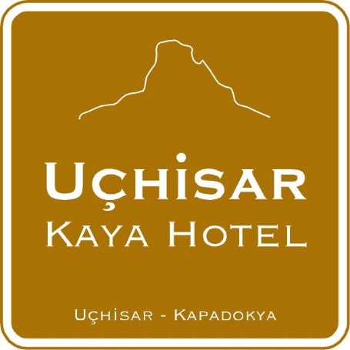
IBAN: EUR : TR70 0013 4000 0015 6497 8000 77
SWIFT: SWIFT Kodu : DENITRIS
BANK NAME: DENIZBANK A.S.
Or if you prefer, you can use the form below to be sent to info@uchisarkayaotel.com.

ACTIVITIY= COCKTAIL
DATE: 16TH MAY
NAME And SURNAME:
PRICE: 15 EUR
FOR PAYMENT YOU CAN SEND US CARD DETAILS

Card Number:

Visa Master Date of Expiry:
CVV

ACTIVITIY= TOUR
DATE: 18TH MAY
NAME And SURNAME:
PRICE: 40 EUR
FOR PAYMENT YOU CAN SEND US CARD DETAILS

Card Number:

Visa Master Date of Expiry:
CVV :

